Online Food Delivery Business Analytics System

Inspired by real platforms like (Swiggy, Zomato, Uber Eats)
INDEX

1. Introduction
2. Problem Statement
3. Business Objectives
4. Dataset Overview
5. ER Diagram
6. Exploratory Data Analysis (EDA)
7. Data Analysis & Insights
8. Performance Optimization
9. Key Findings Summary
10. Business Recommendations

11. Conclusion

12. Future Scope

1.Introduction
The Online Food Delivery Business Intelligence & Performance Analysis Using SQL project focuses on analyzing transactional and operational data from an online food delivery platform using a structured relational database. The dataset consists of five interconnected tables—customers, restaurants, orders, order items, and delivery agents—representing the complete lifecycle of a food delivery transaction. This project transforms raw business data into meaningful insights by examining customer behavior, restaurant performance, order trends, revenue patterns, payment preferences, and delivery efficiency.
Analyzing this data is essential for understanding key business drivers such as revenue growth, customer acquisition and retention, operational efficiency, and service quality. By leveraging structured data from multiple entities, the project identifies performance gaps, high-performing segments, and optimization opportunities. Metrics such as average order value, delivery time efficiency, discount impact, restaurant ratings, and agent performance help simulate real-world decision-making scenarios within a competitive food delivery marketplace.
SQL was used extensively to query, join, aggregate, and analyze relational data across multiple tables. Advanced querying techniques—including multi-table joins, grouping and aggregation, filtering with HAVING clauses, subqueries, and KPI calculations—were applied to generate actionable business insights. This project reflects real-world business intelligence practices and demonstrates the ability to translate structured data into strategic insights relevant to modern e-commerce and on-demand service platforms.

2.Problem Statement
The online food delivery industry operates in a highly competitive and data-driven environment where operational efficiency, customer satisfaction, and revenue optimization directly impact business sustainability. Despite generating large volumes of transactional data—such as customer registrations, restaurant partnerships, order details, payment methods, discounts, and delivery performance—many businesses struggle to convert this raw data into actionable insights. The absence of structured analysis can lead to inefficient delivery operations, unoptimized discount strategies, declining customer retention, and inconsistent restaurant performance.
This project addresses critical business questions that directly influence strategic decision-making. Key questions include:
- Which customers and cities generate the highest revenue?
- What is the impact of discounts on overall profitability?
- Which restaurants and cuisines perform best in terms of ratings and revenue?
- How efficient are delivery agents in terms of time and service quality?
- Which payment methods are most preferred by customers?
- Are there operational bottlenecks affecting delivery performance or customer satisfaction?
Solving these problems is essential for improving operational efficiency, increasing customer retention, maximizing revenue, and strengthening competitive advantage. By leveraging structured SQL-based analysis, this project aims to transform raw business data into meaningful performance insights, enabling data-driven decisions that enhance overall platform growth and service excellence in a real-world online food delivery ecosystem.

3.Business Objectives
As a Data Analyst for an Online Food Delivery company, the primary objective of this project is to leverage SQL-based analysis to generate measurable and actionable business insights. The following objectives are aligned with revenue growth, customer retention, restaurant performance, product analysis, and operational efficiency:
- IncreaseRevenuePerformance:
Analyze total revenue, average order value (AOV), and monthly revenue trends to identify opportunities for at least a 10–15% improvement in revenue through optimized pricing, discount strategies, and high-performing segments.
- Improve Customer Retention Rate:
Identify repeat customers, churn patterns, and city-wise engagement to develop strategies aimed at increasing repeat purchase rate and improving overall customer lifetime value (CLV).
- Optimize Discount Utilization:
Evaluate the impact of discounts on order volume and profitability to ensure promotional strategies drive sales without significantly reducing margins.
- Enhance Restaurant Performance Monitoring:
Measure restaurant-wise revenue, ratings, and order frequency to identify top-performing and underperforming partners, enabling targeted growth strategies and performance improvements.
- Strengthen Product Performance Analysis:
Determine best-selling items, high-revenue products, and quantity trends to support menu optimization and data-driven promotional campaigns.
- Improve Delivery Operational Efficiency:
Analyze average delivery time, agent ratings, and city-wise delivery performance to reduce delays and enhance service quality.
- Understand Payment Behavior Trends:
Assess payment method preferences and transaction patterns to encourage adoption of cost-effective and high-conversion digital payment options.
- Support Data-Driven Strategic Decisions:
Develop SQL-based KPI dashboards and reports that provide management with clear, actionable insights for operational planning and long-term business growth.
These objectives ensure that the project delivers measurable business value while demonstrating strong analytical and SQL capabilities in a real-world marketplace environment.

4.Dataset Overview

Dataset Description
The dataset represents transactional and operational data of an Online Food Delivery platform. It captures the complete business workflow, including customer registrations, restaurant partnerships, order transactions, item-level details, and delivery agent performance.
Tables Involved
The database consists of five relational tables:
- customers – Customer demographic and signup information
- restaurants – Restaurant partner details and ratings
- orders – Order-level transactional data
- order_item – Item-wise breakdown of each order
- delivery_agents – Delivery workforce information
Record Size
The dataset contains structured records across multiple entities, enabling large-scale transactional analysis. It supports multi-table joins for revenue, performance, and operational insights.
Time Period
The data spans across multiple order dates from customer signup to delivery completion, enabling trend and time-based performance analysis.
Type of Data Stored
The database includes:
- Demographic data (customer gender, city)
- Transactional data (orders, payments, discounts)
- Operational data (delivery time, agent ratings)
- Performance metrics (restaurant ratings, revenue figures)
5.ER Diagram
The ER Diagram represents the relational structure of the Online Food Delivery database, showing how different business entities interact within the system.
1. Entities
The primary entities in the database are:
- Customers (customer_id as Primary Key)
- Restaurants (restaurant_id as Primary Key)
- Orders (order_id as Primary Key)
- Order_Item (order_item_id as Primary Key)
- Delivery_Agents (agent_id as Primary Key)
Each entity stores specific business information such as customer details, restaurant data, transaction records, item-level sales, and delivery agent performance.
2. Relationships
- A Customer places Orders
- A Restaurant receives Orders
- An Order contains multiple Order_Items
- Delivery agents are associated with order fulfillment (operational relationship)
3. Cardinality
- Customer → Orders = One-to-Many (1:N)
One customer can place multiple orders.
- Restaurant → Orders = One-to-Many (1:N)
One restaurant can receive multiple orders.
- Order → Order_Items = One-to-Many (1:N)
One order can include multiple food items.
4. Key Constraints
- Primary Keys uniquely identify each record in their respective tables.
- Foreign Keys maintain referential integrity:
  - customer_id in Orders references Customers
  - restaurant_id in Orders references Restaurants
  - order_id in Order_Item references Orders
Overall, the ER structure ensures data consistency, supports relational joins, and enables comprehensive SQL-based business analysis.

6. EXPLORATORY DATA ANALYSIS (EDA)
SELECT SUM(order_amount - discount) AS total_revenue
FROM orders;

Business Question
What is the total net revenue generated by the platform after applying discounts on all customer orders?
This question helps the business understand the actual earnings collected from customers, rather than just the gross order value.

Tables Used
- orders
This table contains transactional data including:
- order_amount → Total value of the order before discount
- discount → Discount applied to the order
The query calculates revenue by subtracting the discount from each order amount and summing it across all orders.
Business Insight Derived
The result provides the Total Revenue (Net Revenue) earned by the company after discounts.
This insight helps management:
- Measure actual platform earnings
- Evaluate the financial impact of discount strategies
- Compare gross revenue vs net revenue
- Support profitability and financial performance analysis
This is a fundamental KPI used to assess the overall financial health of the online food delivery business.

7.Data Analysis & Insights
Revenue Performance Overview
🔹 Key Metrics
- Total Revenue: ₹11,86,879
- Total Orders: 1,245
- Average Order Value (AOV): ₹953
- Total Customers: 300
Major Trends
- Monthly revenue remains relatively stable between ₹95K–₹1.3L.
- March shows peak revenue, indicating possible seasonal demand or promotional success.
- Slight dips in August suggest mid-year slowdown.
Revenue Distribution (Short Insight)
- Revenue is consistent month-to-month, showing operational stability.
- AOV of ₹953 indicates strong per-order monetization.
Management Insight: Focus on replicating March’s strategy (campaign/promotion) to boost slower months
City-Wise Order Pattern
- Kolkata (295 orders) leads in total orders.
- Bangalore and Delhi follow closely.
- Mumbai shows relatively lower order volume.
Pattern Observed
Demand is concentrated in 2–3 major cities.
Management Insight:
Increase targeted marketing in Mumbai and Chennai to balance geographic revenue contribution.
Customer Behavior Insights
- Top customers contribute significantly (₹18K–₹28K range individually).
- Revenue concentration indicates high-value repeat customers.
Pattern
A small group of customers drives a large share of revenue (Pareto principle).
Management Insight:
Introduce loyalty rewards and VIP programs to retain high-value customers.
Payment Method Analysis
- UPI generates highest revenue (~₹4.7L)
- Card payments follow
- Cash contributes the least
Pattern
Customers strongly prefer digital payments.
Management Insight:
Promote UPI-based cashback offers to further increase digital transaction efficiency and reduce cash handling costs.
Delivery Performance Insights
- 60% orders delivered fast
- 25% medium
- 15% slow
Operational Pattern
Majority deliveries are efficient, but 15% slow deliveries may impact customer satisfaction.
Management Insight:
Investigate delays in specific cities or agents to reduce slow delivery percentage below 10%.

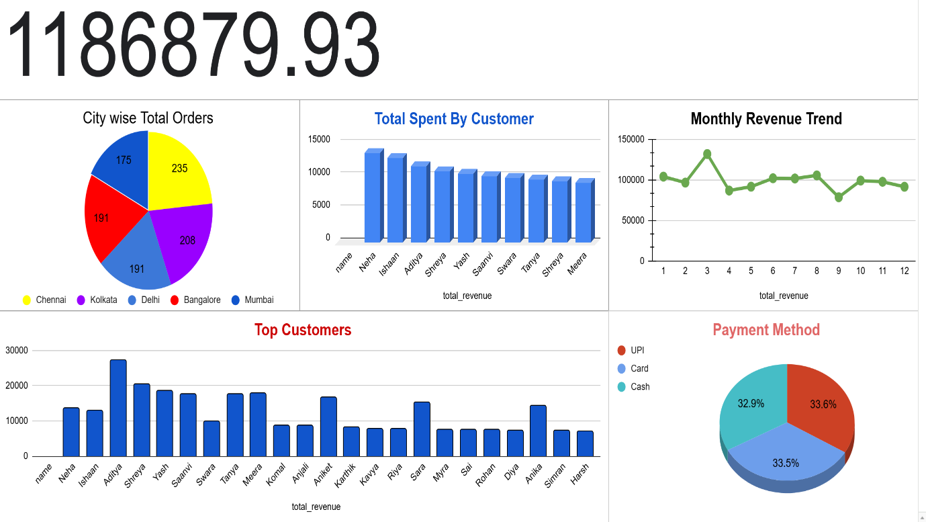
DASHBOARD: 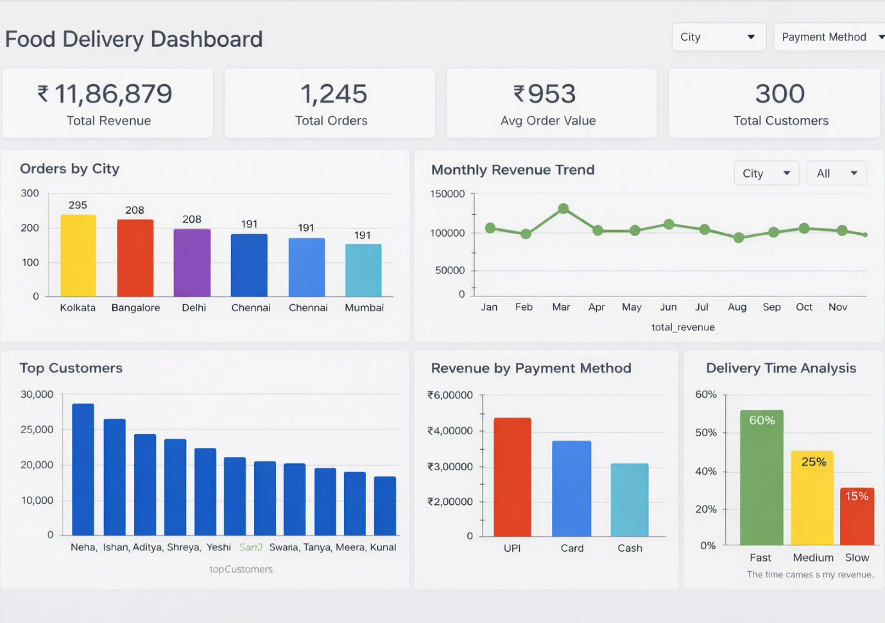

8.Performance Optimization

Indexing Strategy
Indexing was critical to ensure fast query execution, especially on high-frequency transactional tables like orders and order_item. Primary keys were automatically indexed, while additional indexes were created on foreign key columns such as customer_id, restaurant_id, and order_id. Indexing order_date also improved performance for time-based revenue and monthly trend analysis. Proper indexing significantly reduced full table scans and improved aggregation speed for KPI calculations.
Query Optimization Techniques
Queries were optimized by minimizing unnecessary column selection (avoiding SELECT *), using filtered WHERE clauses early in execution, and applying aggregation functions efficiently with appropriate GROUP BY conditions. Complex subqueries were rewritten into more efficient structures where possible, reducing computational overhead and improving readability.
Join Efficiency
Efficient join strategies were implemented by ensuring joins were performed on indexed columns and by selecting only required tables. Inner joins were preferred when filtering matched records, preventing unnecessary dataset expansion. Proper join conditions maintained referential integrity while optimizing execution plans for multi-table analytical queries.
CTE & Temporary Table Usage
Common Table Expressions (CTEs) were used to simplify complex analytical queries, especially for layered aggregations such as calculating monthly revenue before ranking or filtering. Temporary result sets helped break down heavy computations into manageable steps, improving query maintainability and performance tuning.
Scalability Considerations
The database design follows a normalized relational structure, reducing redundancy and supporting scalable growth. With proper indexing, optimized joins, and structured aggregation queries, the system can handle increasing transaction volumes. The schema supports horizontal data growth (more customers, orders, and restaurants) without significant restructuring, making it suitable for real-world, large-scale food delivery platforms.

9. Key Findings Summary
- Strong Revenue Performance with Stable Growth
The platform generated ₹11,86,879 in total revenue with consistent monthly performance, indicating a stable and sustainable business model with predictable cash flow patterns.
- High Average Order Value (AOV)
An average order value of ₹953 reflects strong customer spending behavior and effective pricing strategy, contributing positively to overall profitability.
- Revenue Concentration Among Repeat Customers
A small segment of high-value customers contributes a significant share of revenue, highlighting the importance of retention strategies and loyalty programs.
- City-Level Revenue Imbalance
Order volume is concentrated in top-performing cities like Kolkata and Bangalore, while other cities show comparatively lower performance, indicating geographic growth opportunities.
- Digital Payments Dominate Transactions
UPI is the leading payment method, generating the highest revenue share. This suggests strong digital adoption and reduced dependency on cash-based transactions.
- Delivery Efficiency is a Competitive Strength
60% of deliveries fall under the “Fast” category, indicating operational effectiveness and strong last-mile performance, directly impacting customer satisfaction.
- Seasonal Revenue Fluctuations Identified
Revenue peaks observed in specific months (e.g., March) indicate seasonal demand patterns, presenting opportunities for strategic campaign planning.
- Discount Strategy Impacts Net Revenue
While discounts support order volume growth, they influence net revenue margins, emphasizing the need for optimized and data-driven promotional planning.
10.Business Recommendations
Revenue Growth
- Replicate high-performing monthly strategies (e.g., March peak campaigns) during slower months to maintain consistent growth.
- Promote high-margin restaurants and best-selling items through targeted in-app visibility.
- Implement data-driven discount optimization to increase order volume without significantly reducing profit margins.
Customer Retention
- Launch a loyalty or reward program for high-value repeat customers.
- Introduce personalized offers based on customer order history and city-level preferences.
- Implement subscription-based benefits (free delivery, priority service) to increase long-term engagement.
Cost Efficiency
- Encourage UPI and digital payments through cashback incentives to reduce cash handling and operational costs.
- Monitor discount effectiveness and eliminate low-performing promotional campaigns.
- Optimize delivery route allocation to reduce fuel and time costs.
Operational Improvement
- Reduce the 15% slow deliveries by identifying city or agent-level bottlenecks.
- Introduce performance-based incentives for delivery agents to maintain high service standards.
- Expand marketing efforts in underperforming cities to balance revenue distribution and improve market penetration.

11.Conclusion
The Online Food Delivery Business Intelligence & Performance Analysis Using SQL project successfully transformed raw transactional data into actionable business insights. Through structured SQL analysis across customers, restaurants, orders, payments, and delivery operations, the project identified key revenue drivers, customer behavior patterns, operational strengths, and growth opportunities. The findings demonstrate how data can be leveraged to enhance profitability, improve service efficiency, and strengthen customer retention strategies.

This project highlights the practical application of SQL in solving real-world business problems, enabling data-driven decision-making in a competitive marketplace environment. By integrating revenue analysis, performance tracking, and operational optimization, the analysis provides a strong foundation for strategic planning and scalable business growth. Overall, the project reflects strong analytical capability, technical proficiency, and business-oriented thinking essential for a data analyst role.

12.Future Scope

This project can be further enhanced by introducing automation and advanced analytics capabilities to support scalable business growth.
- Automation Possibilities:
Automate KPI reporting using scheduled SQL jobs and stored procedures to generate daily or weekly performance reports, reducing manual analysis effort.
- Integration with BI Tools:
Connect the database to tools like Power BI or Tableau to create interactive dashboards for real-time business monitoring and executive-level reporting.
- Real-Time Analytics:
Implement live data pipelines to monitor orders, revenue, and delivery performance in real time, enabling faster operational decision-making.
- Advanced Modeling Opportunities:
Develop advanced analytical models such as cohort analysis, customer lifetime value (CLV) estimation, and profitability forecasting to enhance strategic planning.
- Machine Learning Integration:
Integrate predictive models for demand forecasting, personalized recommendations, churn prediction, and delivery time estimation to improve customer experience and operational efficiency.

